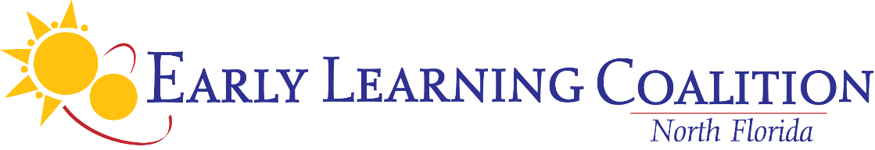
ANNUAL BOARD MEETING

September 9, 2026; 10:30 a.m.

Renaissance Resort World Golf Village Convention Center

Legends 1 Room

Tentative Agenda

*Action Item

- Call to Order/Roll Call

- Public Comment
- ECS Dashboard Report, Teresa Matheny, Chief Strategy & Innovation Officer
- Approval of Delegation of Authority Items*

- Approval of May 7, 2025 Board Meeting Minutes*

- New/Unfinished Business

- Approval of the ELCNF Budget for 2026-2027* HANDOUT
- Approval of ELCNF 2025-2026 Annual Report* -HANDOUT
- RETRO- Approval of the ELCNF insurance coverages with Florida Insurance Trust*
- RETRO-Approval of the Association of Early Learning Coalitions, Inc. Annual Membership Dues*
- Approval of TruTechnology for Managed IT Services Contract Effective October 1, 2026*
- Approval of Faith Based Representative Amy Roberts September 2026 – September 2030*
- Approval of Head Start Director Brian McElhone September 2026 – September 2030
- Review of Board Membership-INFORMATIONAL
- Election of Officers* HANDOUT (To be emailed for nominations prior to meeting)
- Standing Committee Discussion and Sign-Up HANDOUT (To be emailed for sign up prior to meeting)
- Committee Reports

- Staff Reports
- CEO Report
- Finance Manager’s Report HANDOUT
- 4th Quarter Program Update

- Board Absenteeism Log – INFORMATIONAL

- Board Comment

- Next Meetings
- Wednesday, November 4, 2026, 10:30 a.m. – Exec/Admin Committee Conference Call Meeting
- Wednesday, December 2, 2026, 2:00 p.m. – Board Meeting, Renaissance, World Golf Resort and Convention Center

- Adjournment*

