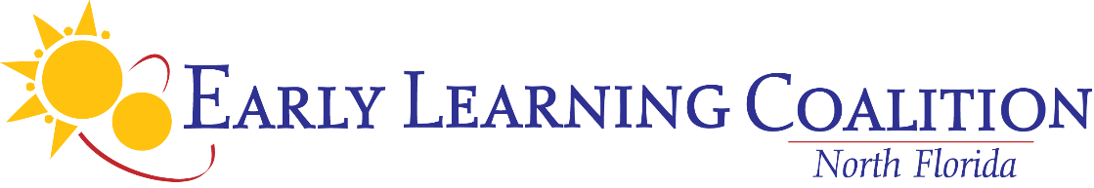

**ANNUAL BOARD MEETING**

September 11, 2024; 10:30 a.m.

*Renaissance Resort World Golf Village Convention Center*

*St. Augustine A Room*

**TENTATIVE AGENDA *Updated 9/10/2024***

***\*Action Item***

1. **Call to Order/Roll Call**
2. **Public Comment**
3. **Provider Recognition**
4. **Approval of Delegation of Authority Items\***
5. **Approval of May 8, 2024 Board Meeting Minutes\***
6. **New/Unfinished Business**
7. RETRO-Approval of the 2022-2024 School Readiness Plan Amendment #09*
8. RETRO-Approval of the ELC of North Florida and the University of Florida/Lastinger Center Contract effective 07/01/2024-06/30/2025*
9. Approval of the Amendment 0001-24 Primary Services Contract Episcopal Children’s Services * **HANDOUT**
10. Approval of the ELCNF Budget for 2024/2025* **HANDOUT**
11. Approval of ELCNF 2023-2024 Annual Report* **-HANDOUT**
12. Approval of the Association of Early Learning Coalitions, Inc. Annual Membership Dues*
13. Retro Approval of TruTechnology for Managed IT Services Contract Effective September 1, 2024*
14. Approval of sending one additional Board member to the National Summit on Education 2024 in Oklahoma*
15. Approval of the Accounting and Financial Policies and Procedures Revisions*
16. Approval of the revisions to the Coalition’s Personnel Policies and Procedures Manual*
17. Approval of private sector Vina Delcomyn term September 2024 – September 2028*
18. Approval of DCF Designee Mala Ramoutar term September 2024- September 2028*
19. Approval of private sector Bailey Steele term September 2024 – September 2028*
20. Approval of private sector Makayla Buchanan term September 2024-September 2028*
21. Approval of Representative for Child Care Providers Lisa Koburger term September 2024 – September 2028*
22. Review of Board Membership-**INFORMATIONAL**
23. Election of Officers**\* HANDOUT (To be emailed for nominations prior to meeting)**
24. Standing Committee Discussion and Sign-Up **HANDOUT (To be emailed for sign up prior to meeting)**
25. Code of Ethics and Conflict of Interest-**HANDOUT (Vendor List to be emailed for review prior to meeting)**
26. **Committee Reports**
27. **Approval of June 26, 2024 Executive Admin Meeting minutes\***
28. **Executive Administrative Committee**
29. Ratify Approval of the 2022-2024 School Readiness Plan Amendment #08**\***
30. Ratify Approval of the ELCNF insurance coverages with Florida Insurance Trust*
31. **Staff Reports**
32. CEO Report

1. Review of ELCNF 2024 Board Self Evaluation Compiled Results- **HANDOUT**

1. Finance Manager’s Report **HANDOUT**
2. 4th Quarter Program Update
3. **Board Absenteeism Log – INFORMATIONAL**
4. **Board Comment**
5. **Next Meetings**

* Wednesday, November 6, 2024, 10:30 a.m. – Exec/Admin Committee Conference Call Meeting
* Wednesday, December 4, 2024, 2:00 p.m. – Board Meeting Renaissance World Golf Village, **Caddy Shack Restaurant**

1. **Adjournment\***