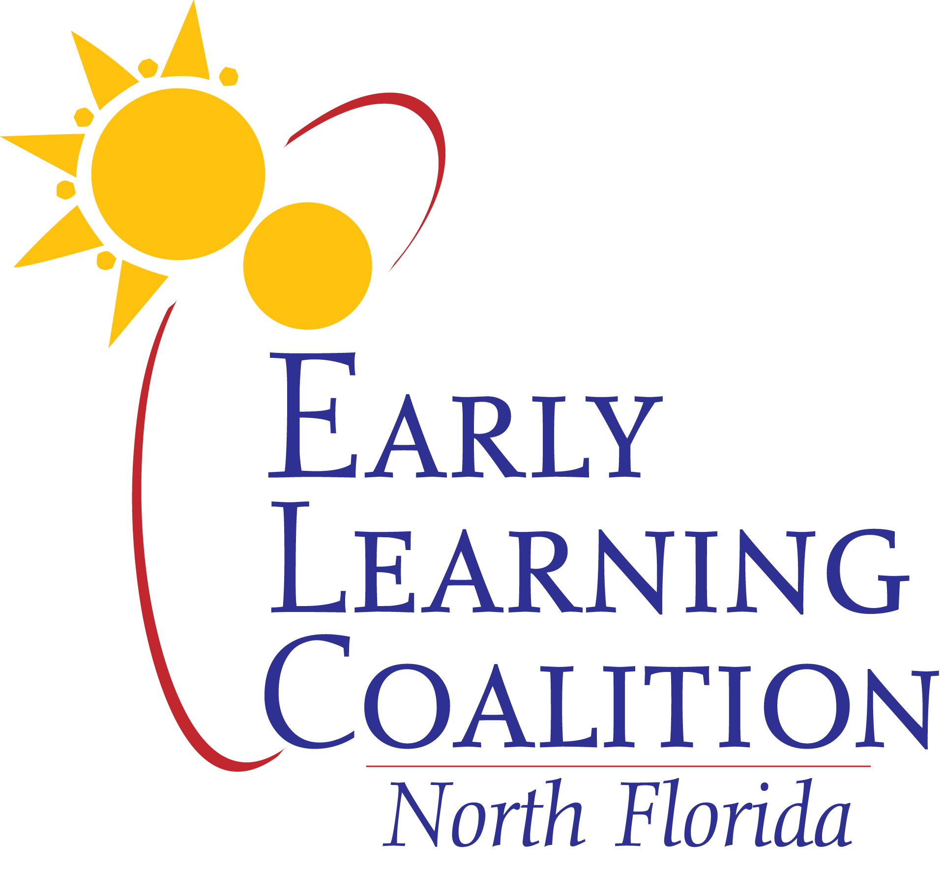
Early Learning Coalition of North Florida, Inc.
2450 Old Moultrie Road, Ste. 103, St. Augustine, FL 32086
PH: (904) 342-2267
FX: (904) 342-2268
www.elcnorthflorida.org

BOARD MEMBERSHIP APPLICATION
DATE:__________________

NAME:
(Please Print)

ADDRESS:
Street City State Zip

MAILING ADDRESS:
City State Zip

PHONE: FAX:

CELL PHONE: Day & month of birthday: _______________

EMAIL:

***************************************************

EMPLOYER:

ADDRESS:
Street City State Zip

MAILING ADDRESS:
City State Zip

PHONE: FAX:

***************************************************
Please indicate where you would prefer Board information to be sent:
Employer Address € OR Personal Address €

COMMENTS:

- Tell us why you would like to serve on the Coalition.

- What concerns do you have relating to early care and education?

- What strengths will you bring to the Coalition?

- Do you or anyone in your immediate family derive an income from a childcare or pre-school program?

- Do you serve on any other boards? If so, please list.

FOR PROVIDERS ONLY:

- Name of the Provider you represent:

- Position:

- Please describe your center and the services provided to Baker, Bradford, Clay, Nassau, Putnam and/or St. Johns Counties.

- Does your center have a religious affiliation (faith-based provider)?

YES

NO

- From what source do the majority of your funds come?

Private

Subsidies

Parent fees

Other

