Be a Reading Pal!
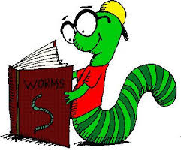
What is a Reading Pal? Reading Pals volunteer at a preschool or child care center once a week to read to a group of children.
Reading to young children sets the groundwork for a child’s future ability to read and learn!

Training is provided; background checks required.
The Early Learning Coalition of North Florida, Inc.
904-342-2267
2450 Old Moultrie Rd. # 103
St. Augustine, FL 32086

Satellite offices in Palatka and Orange Park
The ELC of North Florida serves Clay, Nassau, Bradford, Baker, Putnam and St. Johns Counties
Contact Joan Whitson, Early Literacy Coordinator jwhitson@elcnorthflorida.org
www.elcnorthflorida.org
